OOP Project Proposal

# Bank Al Habib ATM System

# Group Members

1. Ali Hussain – 24K-0578 (leader)

2. Muhammad Ammar–24K-0586

3. Huzaifa Shahid – 24K-0860

# 1. Introduction

Background:

This project simulates an ATM system that performs common banking operations using a graphical user interface (GUI) built using wxWidgets in C++. It also makes use of Python for data analysis, making it a comprehensive project combining OOP principles and data science.

Problem Statement:

Many ATM systems demonstrate poor OOP structure or lack flexibility. This project addresses these limitations by implementing a class-based approach using encapsulation, inheritance, and polymorphism to build an enhanced banking system.

Objectives:

- Build an ATM application using Object-Oriented Programming in C++.  
- Design a responsive GUI using wxWidgets.  
- Store transaction history in CSV files.  
- Analyze and visualize transaction patterns using Python.

# 2. Scope of the Project

Inclusions:

- Account creation, authentication, withdrawal, and deposit features.  
- GUI-based keypad for user input (pin,amount to withdraw etc).

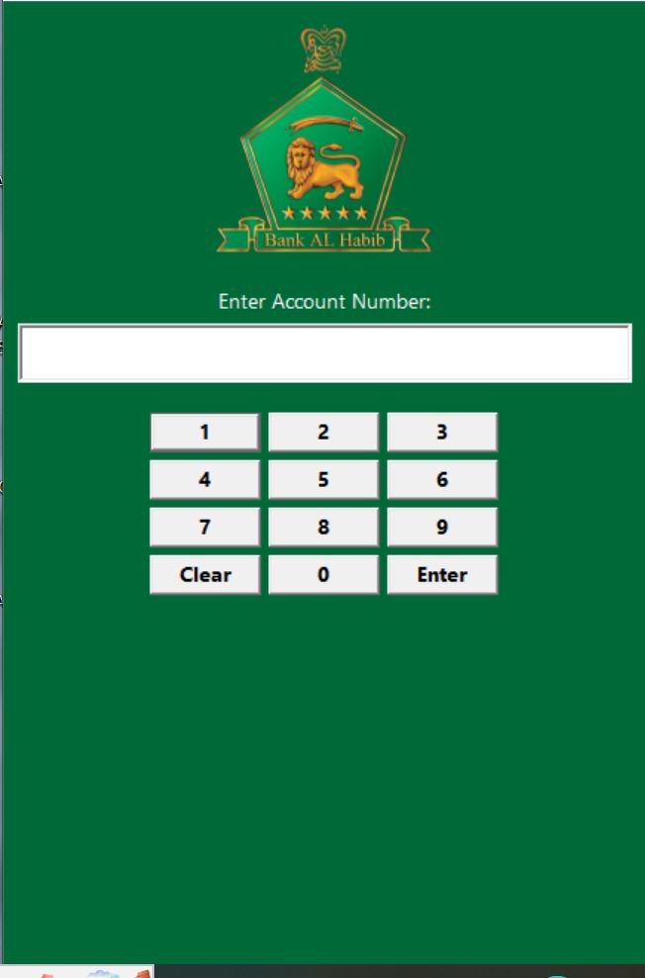

- CSV logging of transactions with timestamps and account details.

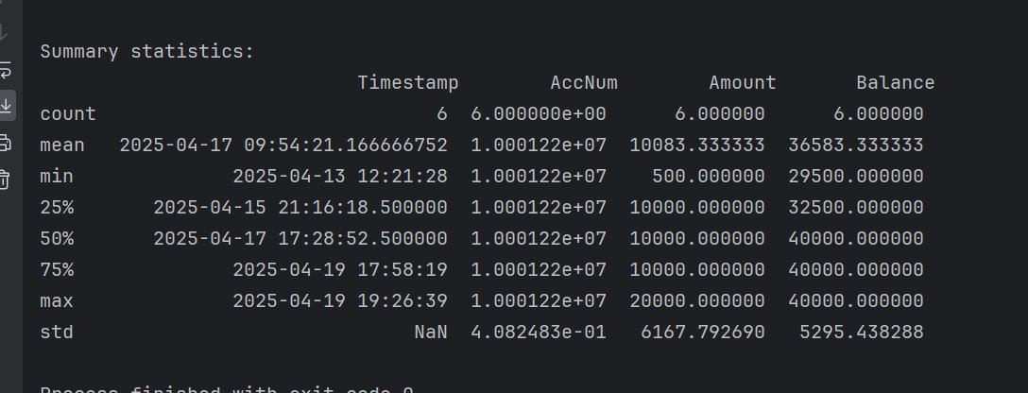

- Graphical analysis of transaction history through Python scripts.

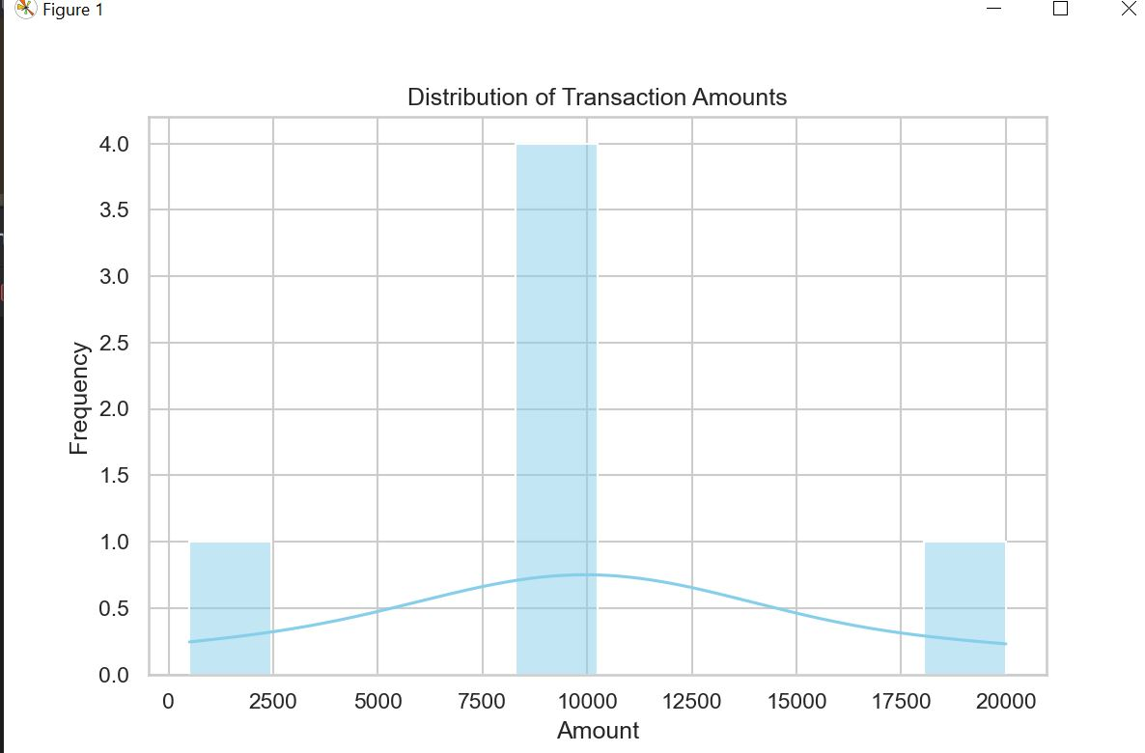

Exclusions:

- No real-time connection to a banking network.  
- No encryption of sensitive data like PINs.  
- No receipt printing feature.

# 3. Project Description

Overview:

The system is a modular ATM simulation with an interactive GUI that uses classes such as BankAccount, Transaction, and Bank. It supports polymorphism through account types like Savings and CurrentAccount. A separate Python script reads transaction logs and produces visual insights such as transaction trends, types, and frequency.

Technical Requirements:

- Visual Studio  
- Libraries: wxWidgets  
- Pycharm

Project Phases:

- Research & Planning: Understanding OOP, GUI design, and Python integration  
- Design: System architecture, class diagrams, and screen layouts  
- Development: Implementing core logic, GUI, and data logging  
- Testing & Visualization: Debugging, validating outputs, and generating analytics

# 4. Methodology

Approach:

We wanted to design a real life data application using the knowledge and skills we learned in this course.Seeing the growing importance of data handling in the modern world, we decided to integrate data analysis into an ATM system which allowed us to demonstrate our understanding of object-oriented programming.

Team Responsibilities:

UML was designed by all the three members collectively. Ali Hussain and Huzaifa Shahid designed GUI using WX widgets by taking help from youtube and GCR uploaded videos, and chat gpt.Lastly, Ali Hussain and Muhammad Ammar added data analysis the help of Python using the following libraries: matplot and sea born for visuals and graphs and pandas for data analysis.

# 5. Expected Outcomes

Deliverables:

- A fully functional ATM simulation with GUI  
- Python-generated reports and graphs from transactions.csv  
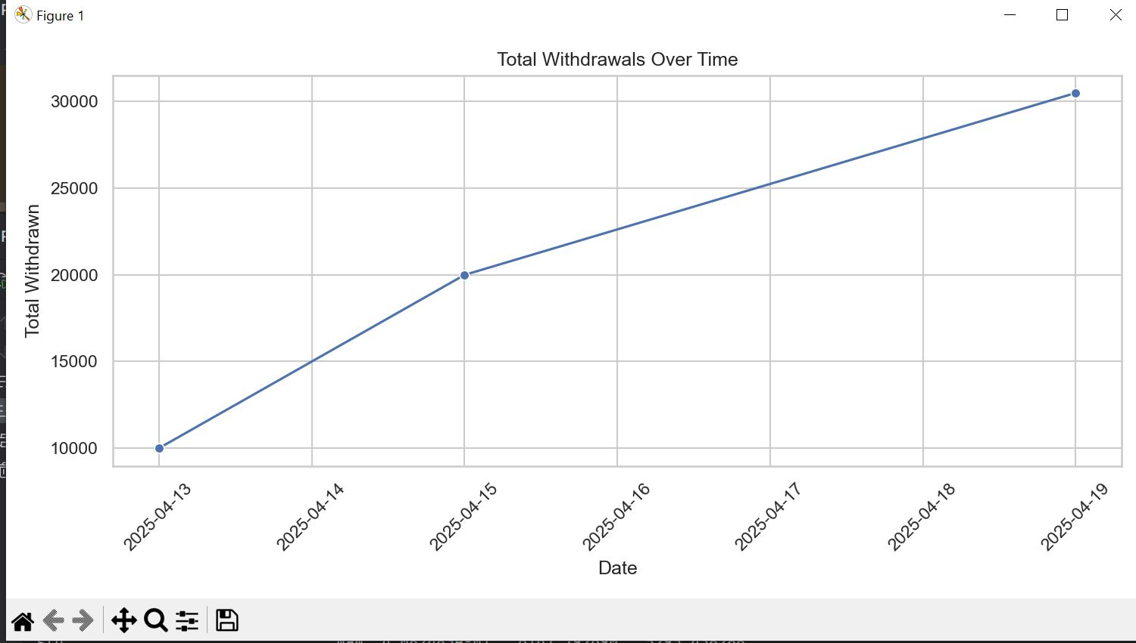

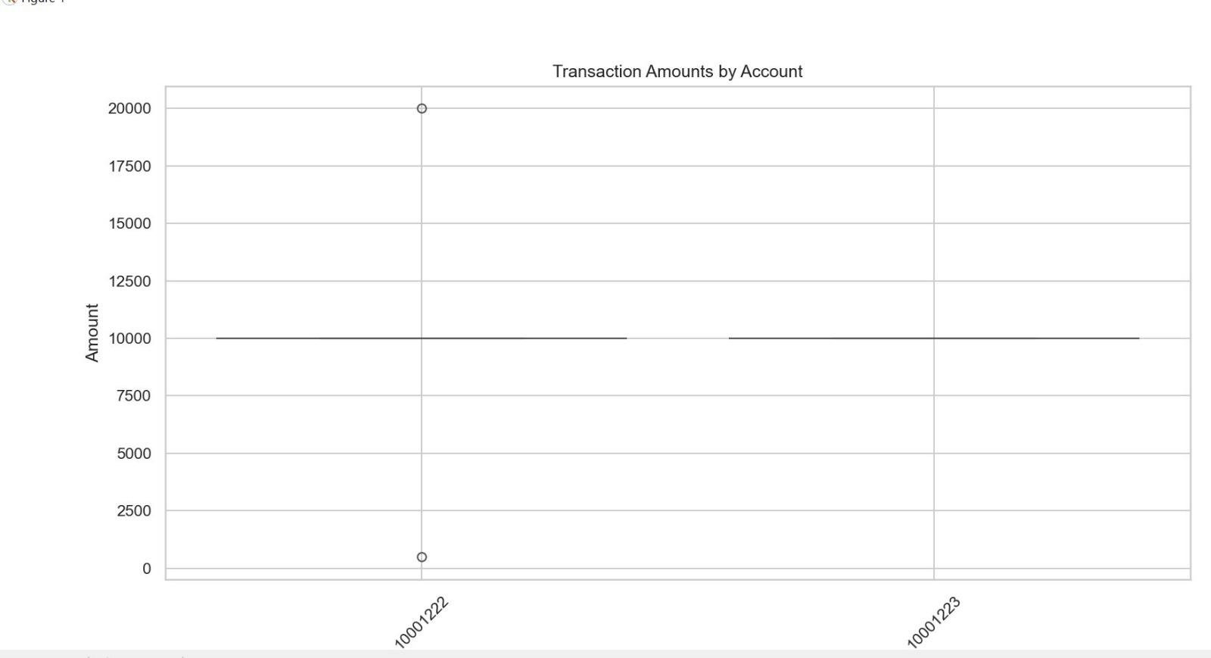

Relevance:

The project makes use of concepts like OOP, filling, and GUI development. It bridges programming and analytics, relevant in today’s data-driven environments.

# 6. Resources Needed

Software:

- Visual Studio  
- wxWidgets library  
- Pycharm

Other Resources:

- Youtube videos regarding GUI and Data Analysis

- Help from Chatgpt to implement GUI  
- Videos on GCR regarding GUI implementation